Black Box Testing

**Functional testing**

1. **Login**
   1. Generic cases

| **Test No.** | **Test Input** | **Actual Output** | **Expected Output** |
| --- | --- | --- | --- |
| 1. | Login with Valid Email and Password | Welcome back+”username” | Welcome back+”username” |
| 2. | Login with vaild unregisterd Email | Firebase: Error (auth/user-not-found) | Firebase: Error (auth/user-not-found). |
| 3. | Login with valid Registered Email and invalid Password | Firebase: Error (auth/wrong-password). | Firebase: Error (auth/wrong-password). |
| 4. | Login with Invalid unregistered Email | Throw relevant error message | Throw relevant error message |
| 5. | Empty Email and Empty Password | Please fill out this field | Please fill out this field |

* 1. Specific cases

| **Test id** | **Email** | **Password** | **Actual Output** | **Expected Output** |
| --- | --- | --- | --- | --- |
| 1. | testuser@gmail.com | testpass | Welcome back+”username” | Welcome back+”username” |
| 2. | testuser@gmail.com | Empty(””) | Please fill out this field | Please fill out this field |
| 3. | testuser | testpass | Please include an ‘@’ in the email address ‘testuser’ is missing an ‘@’ | Please include an ‘@’ in the email address ‘testuser’ is missing an ‘@’ |
| 4. | Empty(””) | testpass | Please fill out this field | Please fill out this field |
| 5. | Empty(””) | Empty(””) | Please fill out this field | Please fill out this field |

1. **Register  
   a.** Generic cases

| **Test id** | **Test Input** | **Actual Output** | **Expected Output** |
| --- | --- | --- | --- |
| 1. | Invalid Email | Throw relevant error message | Throw relevant error message |
| 2. | Registration with already registered email | Firebase: Error (auth/email-already-in-use). | Firebase: Error (auth/email-already-in-use). |
| 3. | Registration with valid email address with valid password | Account added to database | Account added to database |
| 4. | Registration with valid email address with too short password | Firebase: Password should be at least 6 characters (auth/weak-password). | Firebase: Password should be at least 6 characters (auth/weak-password). |

1. **Search**
   1. Generic cases

| **Test id** | **Test Input** | **Actual Output** | **Expected Output** |
| --- | --- | --- | --- |
| 1. | Enter Search Parameters | Relevant Restaurants within a 1.5km radius | Relevant Restaurants within a 1.5km radius |

1. **Join Events**
   1. Generic cases

| **Test id** | **Test Input** | **Actual Output** | **Expected Output** |
| --- | --- | --- | --- |
| 1. | Joining your own event | Not allowed to join the event, followed by Error message | Not allowed to join the event, followed by Error message |
| 2. | Joining a event without logging in | Users not logged in will not even be allowed to access the page (/social) that contains join event | Users not logged in will not even be allowed to access the page (/social) that contains join event |
| 3. | Joining events that are full | Not allowed to join the event, followed by "Capacity already maxed, cannot join!" | Not allowed to join the event, followed by "Capacity already maxed, cannot join!" |
| 4. | Joining events that you have already joined | "You are already part of the event" | "You are already part of the event" |

1. **Create Event**
   1. Generic cases

| **Test id** | **Test Input** | **Actual Output** | **Expected Output** |
| --- | --- | --- | --- |
| 1. | Public Event max numbers = 2 | After 2 people joins, no more can join | After 2 people joins, no more can join |
| 2. | Private Event max numbers = 20 | Event does not appear to users who are not ‘friends’ with event creator | Only can be seen by users who are both follower & following the event creator |
| 3. | Empty Event name, Event duration or description | Popout showing Please fill out this field | Popout showing Please fill out this field |
| 4. | When user not logged in | Popup showing “NOT LOGGED IN” | User should not be allowed to Create the event as he is not logged in |

**Non-Functional testing** Generic cases

| **Test focus** | **Test input** | **Actual Output** | **Expected Output** |
| --- | --- | --- | --- |
| 1 Security | Login with invalid email and password | Firebase: Error (auth/wrong-password). | Firebase: Error (auth/wrong-password). |
| 2 (Reliability, cannot create past event) | Create event on a date that has already passed | Unable to select date | Unable to select date |
| Security | Create event for friends | Option to create a private event | Option to create a private event |
| Security | Registration with less than 6 characters in the password | Firebase: Password should be at least 6 characters (auth/weak-password). | Firebase: Password should be at least 6 characters (auth/weak-password). |

White Box Testing

1. **Login**

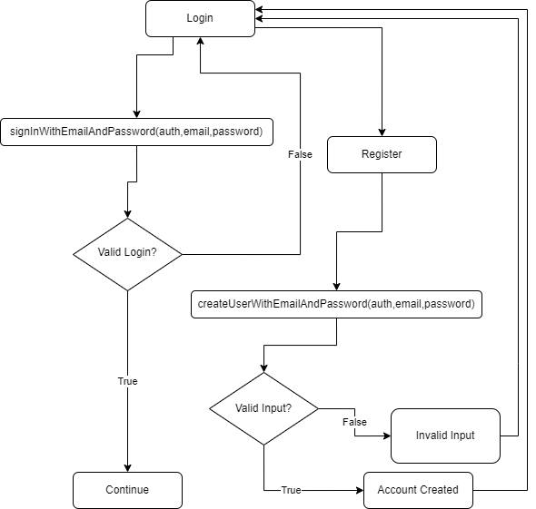

1. **Join Event**